**A level economics**

**Targeted Notes**

We will show you how to make targetted notes for your economics exams, which is quite different from classic note-taking. You will be able to pinpoint the most important areas to revise and make relevant notes. *You won't be drowned in a sea of notes and be puzzled about where to start!* We have categorized the most examined topics from Cambridge Economics (2015 to 2021) past papers. If you are sitting for another exam board (AQA Economics for example) feel free to use this document as a template.

**STEP-BY-STEP GUIDE TO NOTE MAKING**

**Part 1: How to use this document**

1. **Identify keywords**

Each economics question contains specific keywords.

**Content words** cover the whole of the subject area of the syllabus. Their aim is to make clear what is the focus of the question and what you are required to write about.

All content words have been highlighted in different colours.

Here a frequently examined content word is ‘public good’ :

|  |
| --- |
| *Discuss the view that the only goods a government should produce are public goods.* |
| *Explain the features of a public good. Consider whether a motorway (highway) provides an example of a public good* |

Note that the answers for these two questions will be different despite having the same content words.

**This is why it is a bad idea to write pre-prepared answers for your exam!**

1. **Focus on diagrams and definitions**

Diagrams relevant to each topic have been included. Provide your own explanations of these diagrams in your own words. This will help you memorise them.

Remember to define all relevant content words in the first paragraph of your essay. We have provided these definitions for you! (All definitions are from Cambridge books)

1. **Understand the trend**

This document can help you to identify the most examined topics and content words in past exam economics essay questions. This will help you to focus your notes towards specific areas instead of re-writing all your notes from A to Z.

1. **Make notes**

Now that you have achieved all of the above steps. Use your knowledge to make **targeted notes**according to the most examined topics and keywords. This is much more useful than classic notes and this method will pay off!

**Tip: Print this document**

Feel free to print this document (preferably in colour) as many times as required.

**Part 2 : How to make notes**

1. **Examine the highlighted content words**

For example here one of the content words is public goods.

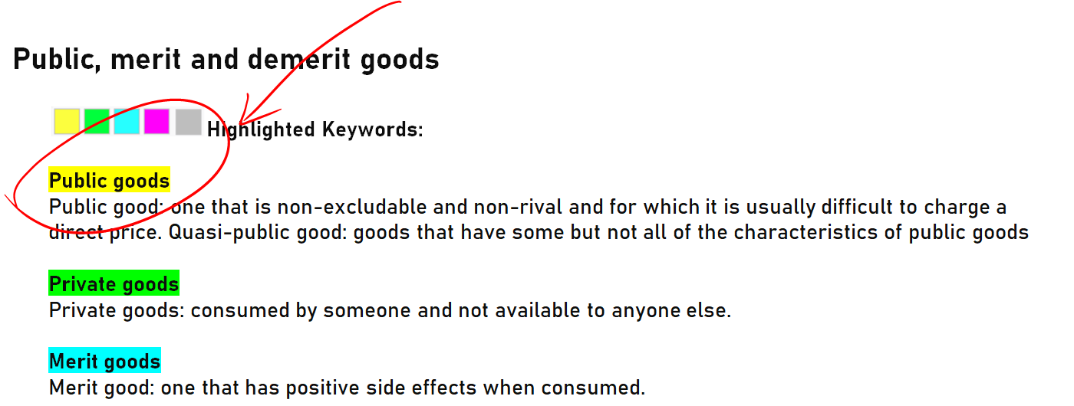

In your notes start by writing a clear definition for this term:



You can use your book or tuition notes as a reference.

1. **Look in what context the questions are asked**

What similarities do these questions have?

|  |
| --- |
| Discuss, with the use of examples, whether a government should directly provide certain goods and services in an economy.[12] |
| Explain the features of a public good. Consider whether a motorway (highway) provides an example of a public good.[8] |
| Using examples, explain the difference between a merit good and a public good. Explain why a profit can be made from the provision of one of these types of good, but not the other.[8] |

They all require you to explain the features of public goods: non-excludable and non-rival.

In your notes, add clear definitions of these two terms



Furthermore, you will notice a trend. It is often asked whether a government should directly provide public goods (and why not the free market).

Those who have revised this chapter know that the 'free-rider problem' must be mentioned. Explain this concept in detail in your notes.

The **free-rider problem** is a type of market failure that occurs when those who benefit from resources, public goods (such as public roads or hospitals), or services of a communal nature do not pay for them...

1. **Add diagrams**

Include any relevant diagrams to the topic. We have already added some frequently used ones but feel free to add more.

1. **Remember**

Doing the above exercise will help you build your own personal toolbox. During the exam, you will pick up some knowledge from this toolbox and apply it to your answer.

No two essay answers will be the same, even if the questions are a similar topic. Hopefully, by doing the above exercise, you will conclude that**it is a bad idea to write pre-prepared answers for your exam!**

**Table of contents**

**Command Words** ...............................................................................................................................................4

Most examined topics from 2015 to 2021

Resource allocation, externalities and market failure 5

Utility 11

Equity and policies towards income and wealth redistribution 16

Firms growth, objectives and survival 17

Market structures 21

Contestable market 26

Labour markets 27

Economic growth, economic development and sustainability 32

Unemployment, recession and inflation 35

National income statistics and classification of countries 38

Developed countries, developing countries and living standards 39

Circular flow of income 41

Investment 42

Money supply 44

Government macroeconomic intervention 47

Inflationary gap and deflationary gap 49

**Command words**

There is a difference between, for example, 'state the advantages of' and 'explain the advantages of'

Examination questions are carefully written to test specific knowledge and skills. They never contain questions such as: 'Write all you know about . . . ' or 'Write as much as you can remember about . . . '

**Calculate**

Work out using the information provided

**Define**

Give the exact meaning

**Describe**

Give a description of

**Identify**

Give an example or key point

**Illustrate**

Give examples or use a diagram

**Outline**

Describe the key point without detail

**State**

Make clear

**Analyse**

Set out the main points and show how they link and connect

**Compare**

Explain similarities and differences

**Explain**

Give clear reasons or make clear

**Consider**

Give your thoughts about, with some differences

**Assess**

Show how important something is

**Comment upon**

Give your reasoned opinions on, with some explanation

**Criticise**

Give an opinion, but support it with evidence

**Discuss**

Give the important arguments, for and against, ideally with a conclusion

**Justify**

Explain why the arguments for an opinion are stronger than the arguments against

**Evaluate**

Discuss the importance of, making some attempt to weight your opinions

**To what extent**

Give reasons for and against, come to a conclusion with a justification of which arguments are strongest and which are weakest

**And**

The word ‘and’ is particularly important in a requirement. It is very easy to read the first part of a requirement, for example ‘Discuss the performance of the business...’ and miss out a further task later on, such as ‘... and state any further information you may find useful

*Command words and definitions are extracted from Cambridge AS and A level Economics book*

# Resource allocation, externalities and market failure

**Common keywords**

Efficiency

Allocation of resources and market failure

Economic Welfare

Government intervention

Free market

**Questions**

|  |  |
| --- | --- |
| ‘Smoking cigarettes causes negative externalities and negative externalities cause market failure which can only be solved by government intervention.’ To what extent do you agree with this statement? [25]  Discuss the view that a firm operating in a perfectly competitive market will achieve economic efficiency but a monopoly firm will not.[13] | 9708/41/M/J/21 |
| Discuss whether competitive markets in the private sector are the best way to achieve an efficient allocation of resources. [25] | 9708/41/M/J/20 |
| ‘Government intervention in the microeconomy always improves efficiency.’ Discuss the validity of this claim. [25] | 9708/42/M/J/20 |
| ‘Free markets make the most efficient use of resources and are the foundation of a successful economy.’ To what extent do you agree with this? [25] | 9708/42/O/N/19 |
| (a) Explain the meaning of and whether there is a link  (i) between Pareto optimality and equality  (ii) between free markets and equity. [12]    (b) Consider the methods a government can use to increase efficiency in resource allocation. [13] | 9708/43/O/N/19 |
| (a) Explain the meaning of and whether there is a link  (i) between externalities and public goods  (ii) between transfer payments and the poverty trap. [12]  (b) Consider whether the existence of externalities in production means that it is impossible to achieve an optimal allocation of resources. [13] | 9708/41/M/J/19 |
| Explain what is meant by ‘market failure’ and consider how far government intervention can reduce market failure. [25] | 9708/42/M/J/19 |
| Governments should use whatever methods they can to regulate monopolies because they are inefficient.’ Consider whether monopolies are always inefficient and what methods might be used by governments to regulate them. [25] | 9708/42/F/M/19 |
| ‘A society that cares about efficiency needs to provide government funds for social sciences that work on the assumption that efficiency matters’. (Royal Society of Arts Journal, Issue 4, 2013)    Explain what is meant by economic efficiency. Consider whether you agree that the only way to achieve economic efficiency is through public sector intervention in the economy. [25] | 9708/41/O/N/18 |
| Discuss whether economic efficiency is always achievable in a market economy. [25] | 9708/42/O/N/18 |
| (a) A dictionary defines efficiency as ‘the power to produce the result intended’. Explain what is intended by achieving economic efficiency and why its attainment is considered important. [12]    (b) Discuss whether it is sometimes necessary to use the public sector to try to achieve economic efficiency rather than the private sector. [13] | 9708/41/M/J/18 |
| A free market economy operates to the benefit of both consumer and producer to achieve the most efficient outcome, and therefore there is no role for a government to play in controlling the market. Consider the extent to which this statement is correct. [25] | 9708/42/M/J/18 |
| (a) Explain why the concept of the margin is significant in the economic theory of consumer behaviour. [12]  (b) Discuss whether the calculation of a marginal cost or an average cost is more significant in reaching conclusions about economic efficiency. [13] | 9708/43/M/J/18 |
| (a) Explain what is meant by equity, allocative efficiency and Pareto optimality. Consider whether they are linked. [12] (b) Discuss whether a better use of resources is always achieved if there is a market structure in which firms remain small. [13] | 9708/42/F/M/18 |
| Discuss whether privatisation and an increase in competition would hinder or help the achievement of economic efficiency. [25] | 9708/41/O/N/17 |
| (a) A country moved from a point within its production possibility curve to a point on its production possibility curve. Explain what is meant by economic efficiency. Analyse what happened to economic efficiency in that country as a result of this movement. [12]  (b) Discuss whether government intervention in the economy is a necessary and sufficient condition for overcoming inefficiency in resource allocation. [13] | 9708/42/O/N/17 |
| In recent years, many countries have faced economic difficulties. At such a time, discovering the best means of allocating scarce resources becomes much more pressing. Consider whether the study of economics has anything to offer to achieve an efficient allocation of resources in a country. [25] | 9708/43/O/N/17 |
| A society that says it cares about efficiency needs to abandon the notion of a market system to allocate resources. Markets only serve self-interest, they are never efficient. Discuss whether this opinion is supported by economic analysis. [25] | 9708/42/F/M/17 |
| ‘Lack of efficiency in the use of resources is not due to the market’s inability to function. It is due to government intervention in a system that is best left to its own workings.’ (Source: RSA Journal, Issue 4, 2013)    Consider this opinion. [25] | 9708/41/M/J/17 |
| Firms should be allowed to produce in the manner they wish and consumers allowed to buy what they believe they want. Discuss whether this is the best means of ensuring an efficient use of an economy’s resources. [25] | 9708/43/M/J/17 |
| Adam Smith’s eighteenth century idea of an ‘invisible hand’ where the free market allocates resources effectively and efficiently is false because the ‘invisible hand’ cannot work in a complex modern economy. Do you agree with this argument? [25] | 9708/41/O/N/16 |
| It has been said that the aim in the allocation of resources should be to achieve the greatest happiness for the greatest number of people. Discuss whether economics has anything to say about the best way to maximise welfare from the use of resources. [25] | 9708/42/O/N/16 |
| ‘The price mechanism is the most effective and certain method for ensuring an efficient allocation of resources to achieve maximum welfare.’ Comment on this opinion. [25] | 9708/43/O/N/16 |
| ‘The best way to increase economic welfare is to encourage competition in a market system.’ Consider whether you agree with this view. [25] | 9708/42/F/M/16 |
| There was a period when many publicly owned enterprises were privatised. Investors said that privatisation would increase competition, encourage greater efficiency and raise profits.    (a) Explain what is meant by economic efficiency. [12]  (b) Discuss how the privatisation of an industry might affect economic efficiency. [13] | 9708/41/O/N/15 |
| International conferences have been held to discuss the effects of global warming and to persuade governments to agree to improve efficiency in the use of resources by limiting the amount of harmful gases produced by their country.    Explain what is meant by an efficient use of resources and discuss whether efficiency can only be achieved if governments are involved. [25] | June 2015 41 |
| The free market is not the way to achieve a sustainable, efficient use of economic resources. Even the famous economist Adam Smith recognised that there was a need for some government involvement.’    Discuss whether government involvement in the economy might overcome the weaknesses of the free market system. [25] | June 2015 42 |
| Economic theory often refers to the concept of equilibrium.    (a) Identify two areas of microeconomic theory that use the concept of equilibrium and explain how in each case that equilibrium is achieved. [12]    (b) Discuss whether economic efficiency is always at its highest if the equilibrium is achieved without any government involvement. [13] | June 2015 43 |

**Definitions and diagrams**

**Efficiency**

Economic efficiency occurs when scarce resources are used in the most efficient way to produce maximum output.

Productive efficiency occurs when a firm is producing at the lowest possible cost.

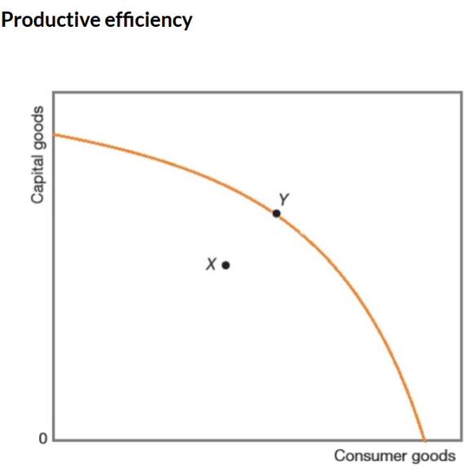

Productive efficiency and perfect competition

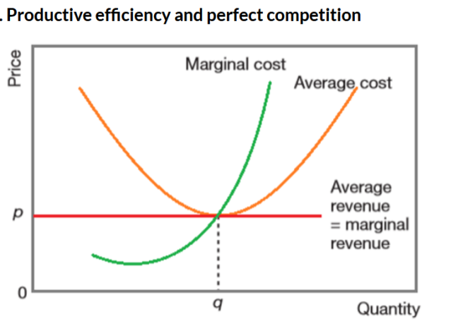

Productive efficiency on a PPC curve

Allocative efficiency occurs when price is equal to marginal cost; firms are producing those goods and services most wanted by consumers.

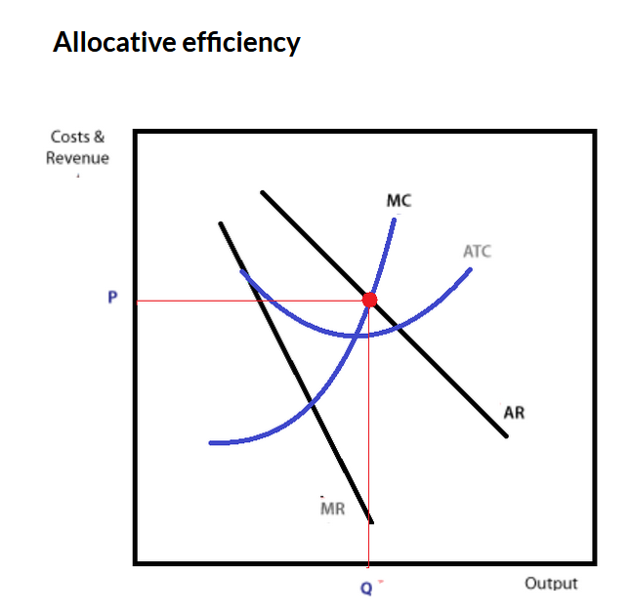

**Allocation of resources and market failure**

Market failure exists whenever a free market, left to its own devices and totally free from any form of government intervention, fails to make the optimum use of scarce resources.

It occurs when the interaction of supply and demand in a market does not lead to productive or allocative efficiency.

There are various reasons why market failure occurs. They include:

* where there are externalities present in the market
* the provision of merit and demerit goods
* the provision of public and quasi-public goods
* information failure
* adverse selection or moral hazard
* abuse of monopoly power in the market

**Economic Welfare**

Market failure can also be understood through an economic concept known as deadweight loss. Th is term refers to the loss of economic welfare. Deadweight loss is the welfare loss when due to market failure desirable consumption and production does not take place.

**Government intervention**

Externality occurs when the benefits or costs to society differ from the benefits or costs to the individual who is responsible for them.

Intervention to correct externalities takes many forms including:

* use of indirect taxes

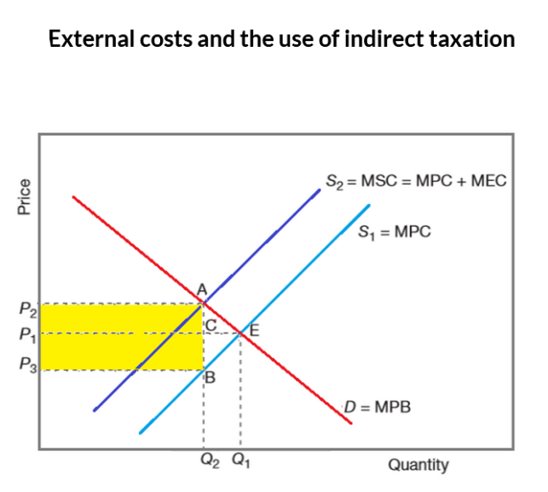

* pollution permits

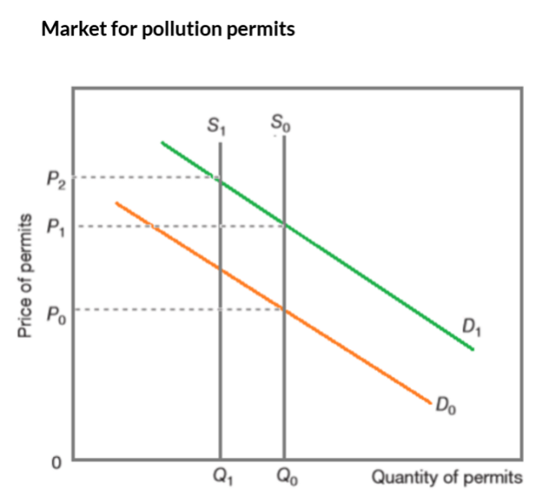

* subsidies

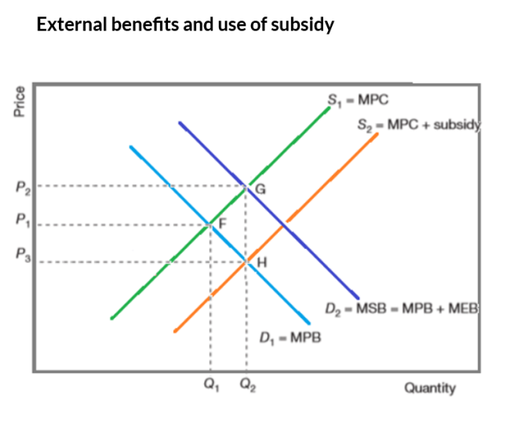

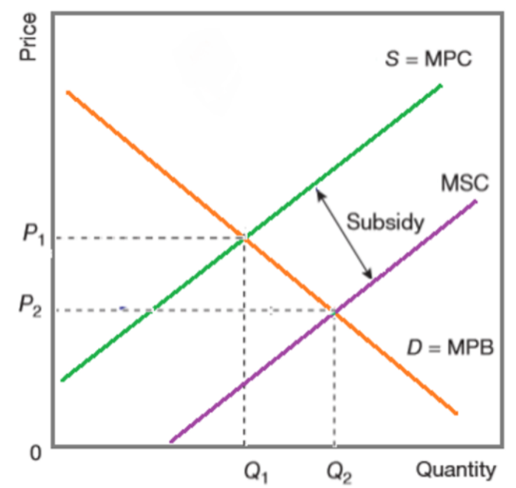

* various types of regulation
* property rights
* provision of information

# Utility

**Common keywords**

Indifference curves

Demand

Normal good

Utility

**Questions**

|  |  |
| --- | --- |
| 3 (a) Explain what is meant by a ‘consumer’s equilibrium position’ in indifference curve theory and how it can be used to form a demand curve. [12]    (b) One of the world’s first filmed singing commercials advertised a soft drink. It stated that, for the same price, consumers would get twice as much of that drink than that of its major rival. This made it cheaper and was similar to a price reduction. Its rival responded by an advertising campaign stating that its own drink was superior to the first firm’s inferior product. Discuss whether it is possible to use diagrams from indifference curve theory to illustrate how a consumer might react to these two advertising campaigns. [13] | May 2020 43 |
| 2 (a) Use indifference curve analysis to explain the derivation of an individual demand curve for a normal good. [12] (b) Discuss, using indifference curve analysis, whether the demand for a good always increases when its price falls. [13] | MAY 2020 42 |
| (a) Explain what is meant by a normal good and comment on the link between total utility, marginal utility and a consumer’s demand curve for that good. [12]    (b) Discuss how a government’s policies toward income and wealth distribution can affect a consumer’s demand. [13] | 9708/42/O/N/19 |
| (a) Explain what is meant by a consumer’s equilibrium and how it is related to the demand for a product. [12]    (b) Indifference curve analysis refers to income and substitution effects. Explain what these effects are and discuss whether they might be the major influence for a manufacturer intending to change the price of a product. [13] | 9708/41/O/N/19 |
| (a) Critically discuss the explanation in economic theory of how a rational consumer exercises choice and how it links to a demand curve. [12] (b) Analyse how a consumer’s equilibrium might change if the government increased a sales tax (goods and services tax) on a normal good, an inferior good and a Giffen good. [13] | 9708/43/O/N/19 |
| (a) Analyse how an individual consumer’s demand curve for a product is derived and consider how this may be linked to its market demand. [12] (b) Use indifference curve analysis to distinguish between the effect of an increase in income on a consumer’s demand for a normal good and an inferior good. [13] | 9708/42/M/J/19 |
| (a) Explain why indifference curves are usually drawn convex to the origin, are downward sloping and do not cross each other. [12] (b) Consider, for an inferior good, the relationship between indifference curves, budget lines, price changes and demand curves. [13] | 9708/42/F/M/19 |
| 3 (a) Explain what is meant by consumer equilibrium and consider whether the assumptions underlying consumer equilibrium are realistic. [12] (b) Analyse the differences between a normal good, an inferior good and a Giffen good. Discuss whether knowledge of these differences is all that is required by a company considering changing the price of its product. [13] | 9708/41/O/N/18 |
| A city bus company proposes to reduce passenger fares. Explain whether consumers always buy more of a good at a lower price than a higher price. Consider what might be the effect on demand for bus journeys and the revenue of the bus company of the lower fares. [25] | 9708/43/O/N/18 |
| (a) Explain, with the aid of a diagram, diminishing marginal utility and its link to indifference curves. [12] (b) Discuss, using indifference curve analysis, how the impact of an increase in indirect taxation on the quantity demanded of a good depends on whether it is a normal or inferior good. [13] | 9708/42/M/J/18 |
| The UK Government has established a behavioural insight team known as the ‘nudge unit,’ which attempts to change consumer behaviour by persuasion. Explain how indifference curve theory predicts a consumer will react to changes in income and changes in the price of a product in order to maximise satisfaction. Consider whether the use of ‘nudge’ theory (persuasion) conflicts with this theory of maximising satisfaction. [25] | 9708/42/F/M/18 |
| 3 Use indifference curves to distinguish between the income and substitution effects of a price change. Discuss whether the distinction might be important for a manufacturer. [25] | 9708/41/O/N/17 |
| (a) Analyse how indifference curve theory explains why a consumer will normally buy more of a good at a lower price than at a higher price. [12] (b) Discuss why there might be exceptions to this normal response, distinguishing the income effect from the substitution effect. Consider the relevance of these exceptions to firms and the government. [13] | 9708/42/O/N/17 |
| (a) Explain why an identical price fall would result in a different demand curve for a normal good from that for an inferior good. Use indifference curve analysis to support your answer. [12]    (b) ‘The only criticism of demand theory is that the consumer is not rational.’ Consider whether you agree with this statement. [13] | 9708/43/O/N/17 |
| (a) Explain what is meant in economic theory by consumer equilibrium. [12] (b) Discuss the conditions that would cause the demand for a good to (i) increase and (ii) fall as a result of a fall in the price of the good. Use indifference curve analysis to support your answer. | 9708/42/F/M/17 |
| (a) Compare the derivation of a demand curve for a product using the marginal utility theory with the derivation using indifference curve theory. [12] (b) Discuss whether the existence of (i) inferior goods and (ii) advertising invalidates the underlying assumptions of those theories of demand. [13] | 9708/41/M/J/17 |
| Choice is an essential part of economics. Sometimes consumers change their choices either when shops have special offers on previously very expensive luxury products, or when advertising persuades them to change their preferences. Analyse how the economic theory of indifference curves can be used to construct a consumer’s demand curve. Discuss whether this theory can explain the above changes in choice. [25] | 9708/42/M/J/17 |
| (a) Explain how utility theory can be used to determine the downward slope of a demand curve. [12] (b) Discuss, using indifference curve analysis, why a decrease in a sales tax on all goods and services might have a different impact on demand for a normal good than for an inferior good. [13] | 9708/43/M/J/17 |
| (a) Explain the meaning of an indifference curve and show to what extent indifference curves can be used to determine a consumer’s demand curve for a product. [12] (b) Consider whether indifference curves can be used to analyse the effects of a fall in the price of a good on the demand for both a normal good and a Giffen good. [13] | 9708/41/O/N/16 |
| (a) A number of consumers are deciding whether to buy a product. How far does economic theory explain the determination of the market demand curve for that product? [12]    (b) Discuss whether that theory is still valid if the producer decides to advertise the product, and consider the effects of the advertising on the demand curve for the product. [13] | 9708/42/O/N/16 |
| The use of indifference curves to establish a consumer’s equilibrium is purely a theoretical tool. They show the relation between two goods; they do not show prices or income and, therefore, cannot be used to determine a demand curve. How far do you agree with this statement? [25] | 9708/43/O/N/16 |
| Choice is an essential part of economics. Sometimes consumers change their choices either when shops have special offers on previously very expensive luxury products, or when advertising persuades them to change their preferences. Analyse how the economic theory of indifference curves can be used to construct a consumer’s demand curve. Discuss whether this theory can explain the above changes in choice. [25] | 9708/42/M/J/17 |
| Consumers decide what they wish to buy and as a result direct the market. Producers develop new products, which they then promote by advertising, in order to maximise profits. Without producers there would be no products to buy. (a) Explain how economic theory predicts what a rational consumer decides to buy. [12] (b) Discuss whether the market is dominated more by producers or by consumers. [13] | 9708/42/O/N/15 |
| With a perfect market and a given income, economic analysis explains how a rational consumer decides the quantities of which products to demand. It cannot, though, explain what happens when incomes change or when businesses in imperfect markets manipulate prices. Discuss whether you agree with this opinion about the economic analysis of consumer behaviour. [25] | June 2015 41 |
| (a) Describe how consumer theory suggests a rise in income will cause a consumer’s demand to change for a normal good and for an inferior good. [12] | June 2015 42 |
| (a) Explain how utility theory can be used to determine the downward slope of a demand curve. [12] (b) Discuss, using indifference curve analysis, why a decrease in a sales tax on all goods and services might have a different impact on demand for a normal good than for an inferior good. [13] | 9708/43/M/J/17 |
| 3 (a) Explain what is meant by a ‘consumer’s equilibrium position’ in indifference curve theory and how it can be used to form a demand curve. [12]    (b) One of the world’s first filmed singing commercials advertised a soft drink. It stated that, for the same price, consumers would get twice as much of that drink than that of its major rival. This made it cheaper and was similar to a price reduction. Its rival responded by an advertising campaign stating that its own drink was superior to the first firm’s inferior product. Discuss whether it is possible to use diagrams from indifference curve theory to illustrate how a consumer might react to these two advertising campaigns. [13] | May 2020 41 |

**Definitions and diagrams**

Indifference curves

An indifference curve shows the different combinations of two goods that give a consumer equal satisfaction

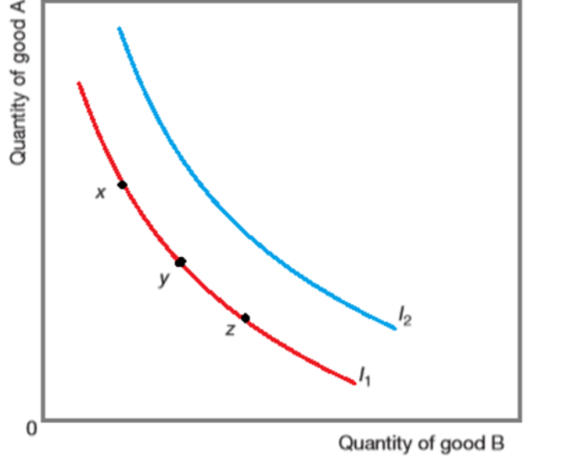

**Demand**

It is possible to use marginal utility to derive an individual demand curve.

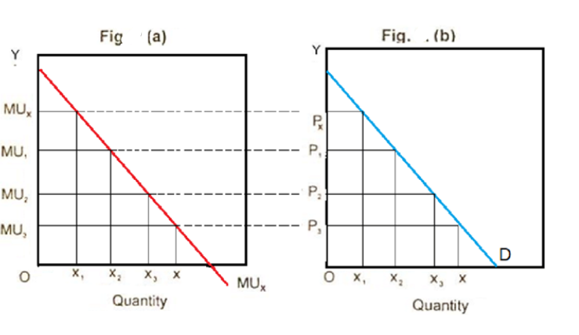

**Normal good**

Normal goods is a good whose demand increases as income increases.

**Utility**

Utility is the satisfaction received from consumption. Total utility is the total satisfaction received from consumption. Marginal utility is the utility derived from the consumption of one more unit of the good or service

# 

# Equity and policies towards income and wealth redistribution

**Common keywords**

Inequality

Income and wealth

**Questions**

|  |  |
| --- | --- |
| Discuss how a government’s policies toward income and wealth distribution can affect a consumer’s demand. [13] | 9708/42/O/N/19 |
| (a) Explain why economists use a Lorenz curve and a Gini co-efficient and comment on likely government policy implications if a country’s Gini co-efficient increased from 0.34 to 0.68. [12] | 9708/41/O/N/19 |
| The Kuznets curve was based upon empirical evidence and it supports the hypothesis that as an economy develops, market forces first increase income inequality and then reduce it.    (a) Explain this hypothesis and consider whether it still applies to both developing and developed economies. [12]    (b) Significant income inequalities continue to exist in developed economies. Evaluate the use of government policy to redistribute income in developed economies. [13] | 9708/43/O/N/18 |
| A Finance Minister wishes to reduce inequalities of income and wealth in the country. Discuss whether fiscal, monetary or supply side policies would be most likely to achieve this aim. [13] | 9708/41/O/N/17 |

**Definitions and diagrams**

**Inequality**

A basic definition of economic inequality refers to the disparities in incomes and wealth in a society.

Lorenz curve is a graphical representation of inequality. Gini coefficient is a numerical measure of inequality.

There are three main types of policies that are available to reduce inequality in the distribution of income and wealth. These are: 1 providing benefits 2 through the tax system 3 through other policies

**Income and wealth**

It is important to distinguish between income and wealth. Income, as we saw is the reward for the services of a factor of production. . For labour, it is paid in wages and salaries or rent, interest and profi ts in the cases of the other factors of production. Wealth is the term used for the accumulation of a stock of assets such as property, shares, bonds or bank accounts

# Firms growth, objectives and survival

**Common keywords**

Profit maximising

Diminishing returns

Marginal cost

Economies of scale

**Questions**

|  |  |
| --- | --- |
| (a) Explain how the fixed and variable costs of a perfectly competitive firm affect its survival in the short and long run. [12]    (b) Explain what is meant by the principal-agent problem and consider its importance in relation to the objectives for a firm. [13] | May 2020 42 |
| Discuss whether profit maximisation is the best strategy in the long run for firms in different market structures. [13] | 9708/42/O/N/19 |
| (a) What relation is there, if any, between the law of diminishing returns and internal and external economies of scale? [12]    (b) ‘It is a general rule that firms maximise profits. They do so where the average revenue from the sale of a product is equal to its marginal cost of production.’ Do you agree with this statement? [13] | 9708/41/O/N/19 |
| (a) Analyse whether there is a link between the marginal cost of a firm and (i) its variable cost; (ii) the supply curve of the industry to which the firm belongs. [12] | 9708/42/F/M/19 |
| (b) Firms do not always wish to maximise profits. Consider what alternative aims they might have and whether the idea of the Prisoner’s Dilemma might be useful in their decision-making. [13] | 9708/41/M/J/18 |
| In recent years the prices of many electronic products have fallen as sales have increased. Research to improve the products is expensive but there are large economies of scale in production. Discuss what is likely to happen to the costs, prices of products and market structure in industries where there are large economies of scale. [25] | 9708/43/M/J/18 |
| (a) Some firms have power over their market. Explain what this means and consider why this power might change in a contestable market. [12]    (b) Discuss the different aims a firm might have in order to continue with production. | 9708/42/F/M/17 |
| (a) Explain the difference between price leadership and price discrimination. [12]    (b) Discuss whether firms always want to maximise profits and are able to do so in the way suggested by economic theory. [13] | 9708/42/M/J/17 |
| (a) Why is it important for a firm seeking to maximise profits to distinguish between the concepts of diminishing returns and economies of scale? [12] | 9708/43/M/J/17 |
| (a) ‘If a firm is experiencing diminishing returns and diseconomies of scale, it means that its output must be decreasing.’ Explain whether this statement is true. [12]    (b) ‘It is certain that firms maximise profits where marginal cost equals marginal revenue, and that this is what all firms seek to do.’ Discuss this assertion. [13] | 9708/42/F/M/16 |
| (a) Analyse the relationship between the cost curves of an individual firm and the supply curve of the industry. [12]    (b) In the long-run, average cost falls with increases in output and, therefore, larger firms are always to be preferred to smaller firms. Do you agree with this opinion? [13] | 9708/41/O/N/15 |
| (a) Explain the meaning of, and the relationship between, diminishing returns, total product and marginal cost. Use a diagram to illustrate your answer. [12]    (b) ‘Firms undertake vertical and horizontal integration to grow in size. They achieve beneficial economies of scale through growth.’Consider whether economies of scale are always caused by integration and whether, therefore, there is no place for small firms in a modern economy. [13] | 9708/42/O/N/15 |
| Economic theory often uses the concept of the margin.(a) Explain how the concept of the margin is used in consumer theory to derive a market demand curve. [12]    (b) Discuss whether the use of the concept of the margin is important for a firm in deciding its business objective. [13] | 9708/43/O/N/1 |
| (a) Explain why manufacturers differentiate their products and describe the characteristics of two market structures where product differentiation occurs. [12]    (b) Analyse and consider the extent of the link between marginal cost, diminishing returns and economies of scale. [13] | June 2015 41 |
| (b) Discuss whether it is always true that a firm, rather than maximising its profits while remaining small, will seek to grow in size. [13] | June 201542 |
| For some products there has been an increasing dominance of large firms in the last five years. For example, in the telecommunications industry most countries now have four or five operators, some have only two. In other markets many small firms exist.    (a) Explain possible reasons why in some markets there are many small firms while in others the market is dominated by a few large firms. [12] (b) Discuss who might benefit and who might lose when a market becomes dominated by a few large firms. [13] | 9708/42/O/N/17 |

**Definitions and diagrams**

**Profit maximising**

Profit earned by a firm is referred to as normal profit and abnormal profit. Th e standard assumption made by economists is that firms will seek to maximise their profits. If the fi rm produces up to the point where the cost of making the last unit is just covered by the revenue from selling it, then the profit margin will have fallen to zero and total profi ts will be at their greatest.

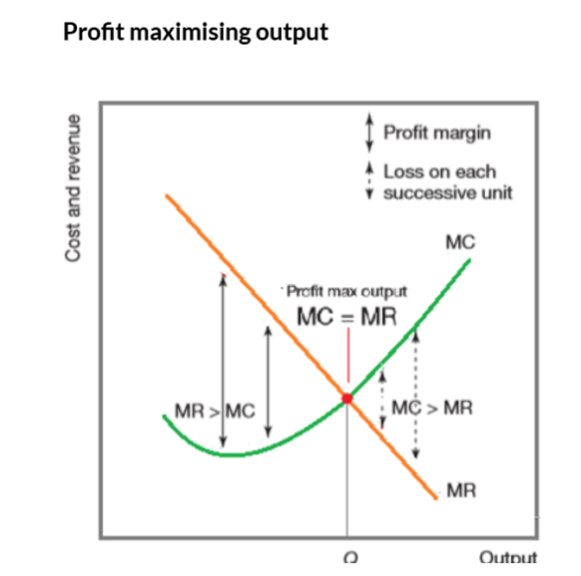

**Diminishing returns**

Diminishing returns is where the output from an additional unit of input leads to a fall in the marginal product. Marginal product is the change in output arising from the use of one more unit of a factor of production.

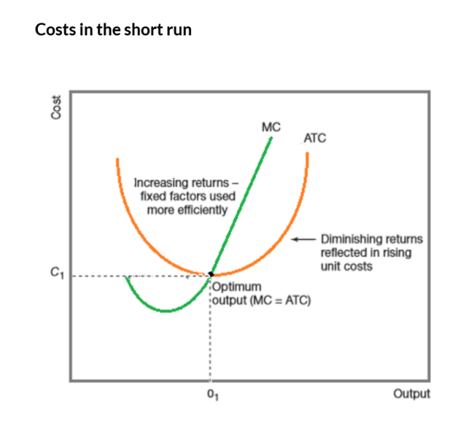

**Marginal cost**

Marginal cost is the addition to the total cost when making one extra unit and is therefore a variable cost.

**Economies of scale**

Economies of scale are the benefits gained from falling longrun average costs as the scale of output increases

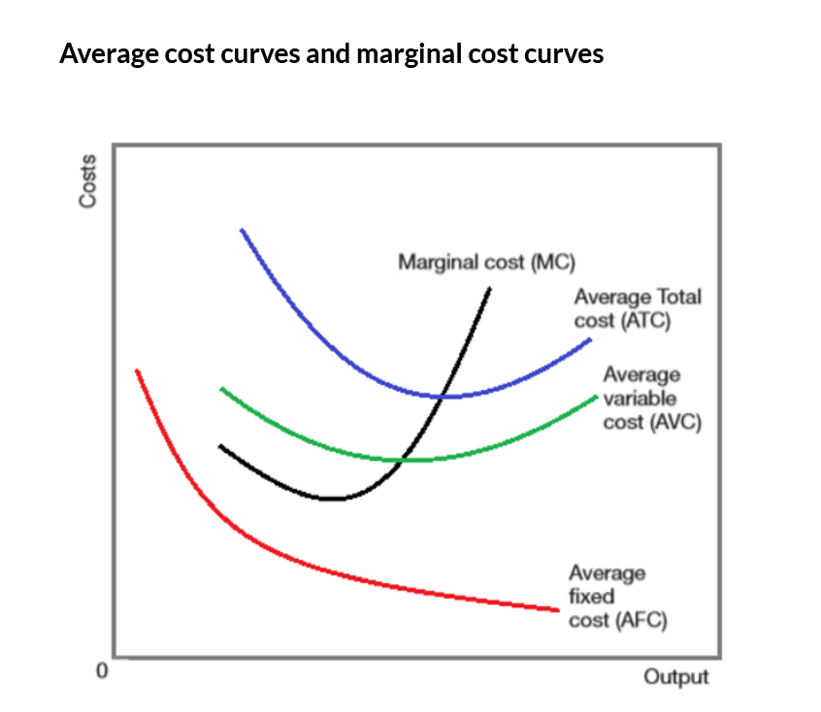

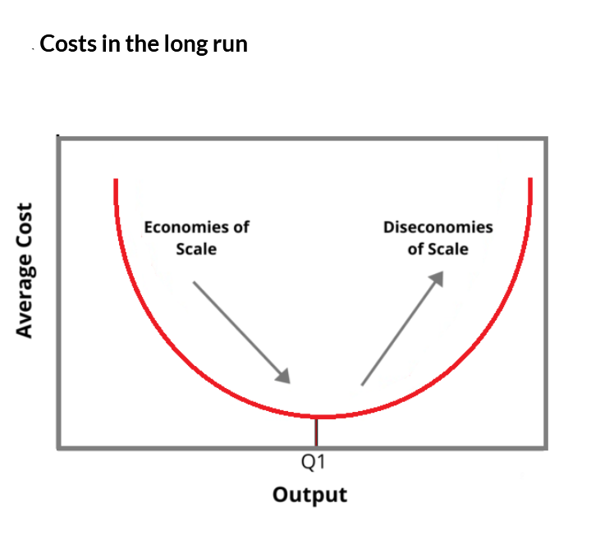

# Market structures

**Common keywords**

 Perfectly competitive

Maximising profit

Monoopoly

Oligopoly

Monopolistic

market structure

**Questions**

|  |  |
| --- | --- |
| ‘A firm in a perfectly competitive market can make either a supernormal profit or a loss in the short run but will only make normal profit in the long run.’ Assess whether this statement is true.[12]  Discuss the view that a firm operating in a perfectly competitive market will achieve economic efficiency but a monopoly firm will not.[13] | 9708/42  March 2021 |
| ‘A firm is fully aware of market conditions and its best rational interest would be achieved by pursuing the clearly defined objective of maximising profits.’ Consider whether this statement has any merit in different market structures. [25] | May 2020 43 |
| Explain how a firm maximises its profit in perfect competition. [12] | 9708/42/O/N/19 |
| ‘Competition is an essential element of an efficient market economy. If there is a monopoly then there is no competition. Monopolies exist in all economies and, therefore, all economies must be inefficient.’ Discuss this opinion. [25] | 9708/41/O/N/19 |
| (a) Contrast the features of a perfect competitive market with those of an oligopoly and compare the aims of the firms in each of these market structures. [12] (b) Discuss what you would expect to happen to the output of the industry and the level of profit if perfect competition were replaced by a monopoly. [13] | 9708/43/O/N/19 |
| (a) Explain what is meant by ‘the principal–agent problem’ and analyse why it is likely to be found in some market structures and not others. [12]    (b) Explain what is meant by a contestable market and discuss whether a firm in a contestable market necessarily aims to maximise its profit. [13] | 9708/41/M/J/19 |
| A recent newspaper article commented on the fact that a pharmaceutical company charged customers in the United States (US) US$800 per treatment whilst it charged customers in Egypt US$80 for the same treatment. (a) Explain why the company might follow this policy and what conditions are necessary to allow the policy to be successful. [12] (b) Discuss whether oligopolistic industries always operate against the interests of consumers. [13] | 9708/42/M/J/19 |
| (b) Discuss how the objective of a firm in an oligopolistic market might differ from the objective of a firm in a perfectly competitive market. [13] | 9708/42/F/M/19 |
| (a) Analyse the factors which determine the price of a firm’s product and its output in monopolistic competition. [12] (b) Assess the effect on output and price if a monopoly firm maximises its sales revenue rather than its profit. Consider who will benefit the most from this change. [13] | 9708/42/O/N/18 |
| (a) Two major hotel groups agreed to charge a lower rate for rooms booked through a booking agent than if guests asked for a room upon arrival at the hotel. Explain how price discrimination can occur and how it can be profitable and consider whether the above situation is an example of price discrimination. [12]    (b) It has been said that where monopoly occurs rather than a competitive market, the public is the victim; prices are high and output is restricted. With the help of a diagram, consider how far economic theory can be used to support this statement. [13] | 9708/43/O/N/18 |
| (a) Explain the difference between perfect competition and monopoly and, with the help of diagrams, distinguish between normal profit and supernormal profit, considering whether supernormal profit is possible in perfect competition. [12] | 9708/41/M/J/18 |
| 3 A businessman claimed it was difficult to make decisions as his business was subject to uncertainty and interdependence. Discuss the methods used by oligopoly firms to reduce uncertainty and interdependence and the extent to which these methods exploit the consumer. [25] | 9708/42/M/J/18 |
| In 2016, a country’s largest yacht builder said it would have to make 350 people redundant. The company, which builds luxury yachts, said demand had decreased in the recession. (b) The price of the company’s product was above the average total cost. Discuss whether in an imperfectly competitive market structure a firm’s aim would necessarily mean it would stop production if the price has to fall because of reduced demand. [13] | 9708/42/F/M/18 |
| Consider whether a firm’s marginal cost and average variable cost are significant when a firm wishes to maximise profits. [12] (b) Analyse how firms are said to behave in an oligopolistic market. Discuss how an understanding of ‘the prisoner’s dilemma’ can help to demonstrate the concept of interdependence in an oligopolistic market. [13] | 9708/41/O/N/17 |
| (a) Describe how a firm is said to operate in order to maximise profits. Consider whether it will cease to operate if total revenue fails to cover total cost. [12] (b) Some large supermarkets publicise the fact that they ‘price match’ other major supermarkets, charging the same prices for the same brands of products as their competitors. Analyse how firms are said to behave in oligopolistic markets. Discuss how far this is supported by the above statement. [13] | 9708/43/O/N/17 |
| The driving force of some governments is to bring the benefits of competition to formerly monopolised markets. (a) Explain the benefits that might occur in a more competitive market compared with a monopolised market. [12] (b) Discuss why competitive markets in the private sector are not always the most efficient means of deciding how to employ a country’s resources. [13] | 9708/42/M/J/17 |
| (b) Analyse and discuss how the market price and quantity supplied might change if a profit maximising firm in a perfectly competitive market were able to achieve a monopoly status in that market. [13] | 9708/43/M/J/17 |
| (a) Explain how an equilibrium position is determined for a firm and for an industry in perfect competition in the short run and in the long run. [12] (b) Outline the conditions that make price discrimination in a monopoly market possible and discuss whether such discrimination is ever beneficial. [13] | 9708/41/O/N/16 |
| Explain what is meant by the ‘equilibrium of a perfectly competitive firm’ and consider the view that equilibrium is always achieved in perfect competition but never in a monopoly market. [25] | 9708/42/O/N/16 |
| (a) Assess the differences and the similarities in characteristics, pricing and output between perfect competition and monopolistic competition. [12] (b) Consider whether it is true that prices are always higher and output always lower under monopoly conditions than they are under perfectly competitive conditions. [13] | 9708/43/O/N/16 |
| (a) Analyse, with the help of a diagram, the possible shape of the long-run average cost curve of a firm and explain whether it is likely to be the same for small and large firms. [12] (b) Two airlines were recently accused of colluding to exploit the consumer. An investigation was established to see if this had happened.Discuss why collusion can occur in one market structure but not in another market structure.[13] | 29708/43/O/N/15 |
| (a) A firm in a perfectly competitive market and a firm with a monopoly both seek to maximise their profit. Explain, with the help of a diagram, why the levels of price and output might be different in the two markets. [12] | June 2015 42 |

**Definitions and diagrams**

**Perfectly competitive**

Perfect competition is an ideal market structure that has many buyers and sellers, identical or homogeneous products, no barriers to entry

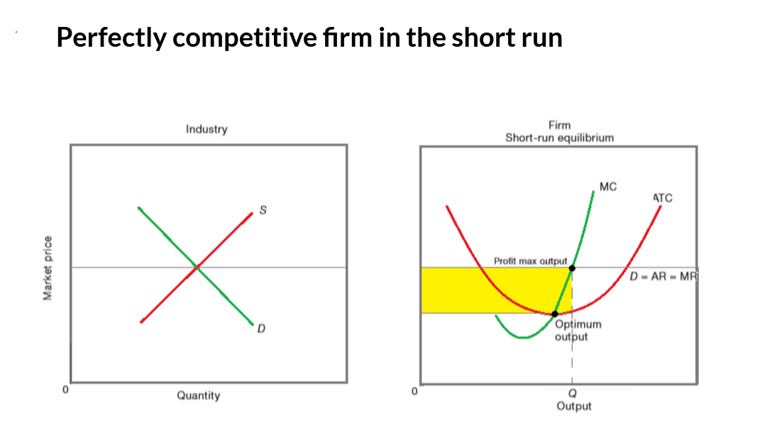

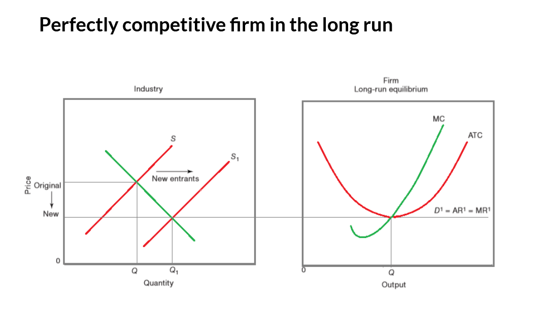

**Maximising profit**

Profit earned by a firm is referred to as normal profit and abnormal profit. Th e standard assumption made by economists is that fi rms will seek to maximise their profits. If the firm produces up to the point where the cost of making the last unit is just covered by the revenue from selling it, then the profit margin will have fallen to zero and total profi ts will be at their greatest.

**Monoopoly**

A pure monopoly is just one firm in an industry with very high barriers to entry

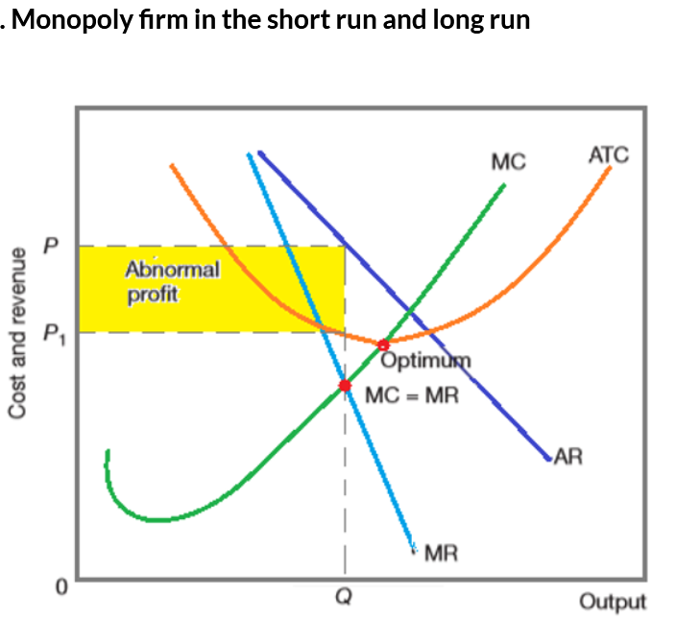

**Oligopoly**

Oligopoly is a market structure with few firms and high barriers to entry.

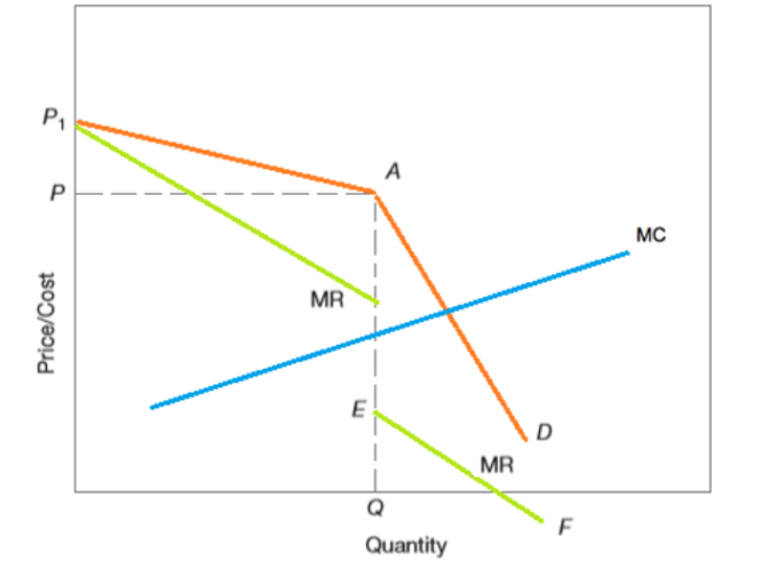

**Monopolistic**

Monopolistic competition is a market structure where there are many firms, differentiated products and few barriers to entry.

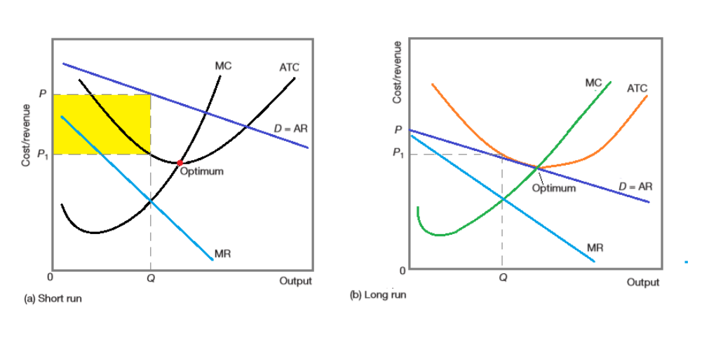

**market structure**

Market structure is the way in which a market is organised in terms of the number of firms and the barriers to the entry of new firms. The four models of market structure are perfect competition, ,monopolistic competition and oligopoly

# Contestable market

**Common keywords**

Contestable market:

A contestable market is any market structure where there is a threat that potential entrants are free and able to enter this market

**Questions**

|  |  |
| --- | --- |
| (a) Explain what is meant by ‘the principal–agent problem’ and analyse why it is likely to be found in some market structures and not others. [12] (b) Explain what is meant by a contestable market and discuss whether a firm in a contestable market necessarily aims to maximise its profit. [13] | 9708/41/M/J/19 |
| (a) Some firms have power over their market. Explain what this means and consider why this power might change in a contestable market. [12] (b) Discuss the different aims a firm might have in order to continue with production. | 9708/42/F/M/17 |

# Labour markets

**Common keywords**

 Wage determination/ theory of wages and Perfect/ imperfect labour market

Labour demand and/or supply

**Questions**

|  |  |
| --- | --- |
| Distinguish between transfer earnings and economic rent. With the help of diagrams, consider the links between transfer earnings, economic rent, the elasticity of supply of labour and an individual worker’s wage rate.  ‘Trade unions can gain an increase in wage levels only at the expense of higher levels of unemployment.’ To what extent do you agree with this statement? | March 2021 42 |
| After negotiation, the workers in an industry obtained from employers higher wage rates. The employers’ spokesperson said ‘the cost of the deal would have to be met through improved productivity or by reductions in other costs’. Analyse whether this deal can be incorporated into the economic theory of wages and consider the possible outcome for employment of such a deal. [25] | May 2020 41 |
| Explain the relevance of economic rent and transfer earnings when comparing the wages of skilled workers and unskilled workers. [12] Discuss whether workers always benefit when their trade union achieves an increase in wages. [13] | 9708/42/O/N/19 |
| (a) Explain why economists use a Lorenz curve and a Gini co-efficient and comment on likely government policy implications if a country’s Gini co-efficient increased from 0.34 to 0.68. [12] (b) With the help of a diagram analyse what is likely to happen to a worker’s transfer earnings and economic rent if a perfectly competitive labour market is replaced by a monopsony. [13] | 9708/41/O/N/19 |
| Analyse and discuss whether the economic theory of wages can explain why there are inequalities in wage rates in a country. [25] | 9708/43/O/N/19 |
| ‘A rise in wages and salaries will increase the costs of production, decrease profits, cause inflation and is detrimental.’ Discuss whether the economic theory of wage determination supports the view that an increase in the level of wage rates is detrimental for the firm and for the worker. [25] | 9708/41/M/J/19 |
| (a) According to economic theory, what is the significance for a firm in a perfectly competitive labour market of a worker’s marginal product and average product? [12] (b) Discuss the economic conditions that might make it possible for a trade union to increase the wages of its members without reducing the number of workers employed. [13] | 9708/42/F/M/19 |
| (a) Explain the economic theory of wage determination in perfectly competitive labour markets. [12] (b) In 2016, a union representing doctors organised strikes to oppose new contracts and rates of pay that were proposed by the government. Hospital appointments were cancelled. The government agreed to change some of the proposals. Does this statement prove that in imperfect labour markets wages are determined solely by trade unions and not by economic principles? [13] | 9708/41/O/N/18 |
| Consider whether wages are only determined by the market forces of supply and demand. [25] | 9708/42/O/N/18 |
| Discuss how economic theory analyses wage rate determination. Consider if the theory can be used to explain the fact that the highest pay is often given for the work that is most agreeable while those occupations that are most unpleasant, such as rubbish collection, receive low pay. [25] | 9708/43/O/N/18 |
| Trade unions, minimum wage legislation and large powerful businesses invalidate the conclusions of the traditional economic theory of wage determination. The theory needs to be replaced. How far do you agree with this assertion? [25] | 9708/41/M/J/18 |
| (a) Explain how a firm derives its demand curve for labour and consider how the structure of the product market in which the firm operates affects the firm’s demand curve for labour. [12] (b) Discuss whether it is possible for a trade union to negotiate higher wages and more employment. [13] | 9708/42/M/J/18 |
| In 2016, a country’s largest yacht builder said it would have to make 350 people redundant. The company, which builds luxury yachts, said demand had decreased in the recession. (a) Explain, with the help of a diagram, how this situation could be incorporated into the marginal revenue productivity theory of wage and employment determination. [12] | 9708/42/F/M/18 |
| Explain the relationship in a perfect market between a firm’s demand for labour and the wage rate offered. [12] (b) Discuss how a firm’s demand for labour and the wage rate might change if the market were to become imperfect. [13] | 9708/41/O/N/17 |
| The merit of the economic theory of wage determination is that it clearly shows what the best level of wage rates should be and thus is evidence that there is no need for either the government or trades unions to fix wages. Discuss this assertion. [25] | 9708/42/O/N/17 |
| The French film industry is subsidised by the government. Some actors receive very high fees. In 2015 it was proposed that, as part of the fee is public money, some of the subsidy should be withdrawn. Discuss what might happen to employment and wages if a subsidy for production were reduced. Use the economic theory of wage determination in perfect and imperfect labour markets to support your answer. [25] | 9708/43/O/N/17 |
| A politician remarked that the absence of trades unions would necessarily lead to an improvement in all labour markets. To what extent does economic analysis support this remark? | 9708/42/F/M/17 |
| Economic theory produces a precise equilibrium outcome, often in an idealised market situation, but in reality things are much less certain. Discuss whether this opinion can be applied to the determination of wage rates. [25] | 9708/41/M/J/17 |
| Analyse the difference shown by marginal revenue productivity theory between wage determination in perfect and imperfect labour markets. Discuss the proposition that, in imperfect markets, a trade union can only increase the wage rate by allowing a reduction in employment. [25] | 9708/43/M/J/17 |
| In 2014, the average monthly salary in South Africa for an executive business manager in the private sector was 60 000 rand; for a public sector nurse, 13 700 rand; for a cleaner, 3 600 rand. These differences in wage rates can be entirely explained by the economic theory of the labour market. Discuss whether you agree with this conclusion. [25] | 9708/41/O/N/16 |
| (a) Some occupations that do not have pleasant working conditions, such as rubbish collection, receive low pay, while those with pleasant conditions, such as senior managers, receive high pay. How far does economic analysis explain this situation? [12] (b) Discuss what influence a trades union and a government can have in determining wage rates. [13] | 9708/42/O/N/16 |
| (a) With the help of a diagram, explain how far the introduction of a minimum wage in an occupation might affect the division between a worker’s transfer earnings and economic rent. [12] (b) Discuss how far wage differentials are caused in the real world solely by differences in market demand and supply. [13] | 9708/43/O/N/16 |
| (a) Discuss how wage rates are determined in a perfect market. [12] (b) If the labour market is imperfect, is the determination of wage rates still better left to that market? [13] | 9708/42/F/M/16 |
| The economic theory of wages has as its central idea the achievement of an equilibrium in a perfect market. It is difficult to find a perfect market and it is unrealistic to speak of an equilibrium when private enterprise is full of uncertainty.’Discuss whether this statement means that in explaining wage determination the theory has nothing to offer. [25] | 29708/41/O/N/15 |
| (a) Distinguish between supernormal profit and economic rent and consider the circumstances when each occurs. [12] (b) Discuss whether you agree with the opinion that a trade union might be able to achieve higher wages for its members but only by causing some unemployment. [13 | 49708/42/O/N/15 |
| Briefly consider the causes of unemployment and then use the economic theory of the determination of wage rates to discuss whether an increase in wage rates may substantially increase long term unemployment in some industries but not in others. [25] | 9708/43/O/N/15 |
| (a) How does economic analysis explain the level of wage rates in a perfectly competitive labour market? [12] (b) Here are two press statements. ‘A government announced that it would limit the top level of pay for senior executives in private industries by imposing a maximum wage.’ ‘The trade union for transport workers decided to call a strike unless its members were awarded a higher rate of pay.’ Source: The Telegraph Business, March and October 2012 Discuss how the economic analysis of wage determination would be changed by the announcement of the government and the decision of the trade union. [13] | June 2015 41 |
| ‘Wage determination in the factor market is just like price determination in the product market. It is entirely dependent on the forces of supply and demand.’ Do you agree with this statement? [25] | June 2015 42 |
| ‘Labour is a resource; the use of resources increases economic wellbeing. The main aim of the government of a developing country keen to increase wellbeing should, therefore, be to support an increase in the population of its country.’ Discuss this argument and decide whether you agree with it. [25] | June 2015 43 |
| Economic theory is often very precise in its explanation but not very useful in its application to reality. (a) Explain why, in perfectly competitive labour markets, the economic theory of wage determination is very precise. [12] (b) Discuss whether in reality such precision is found in the imperfect market structures of actual labour markets. [13] |  |

**Definitions and diagrams**

**Wage determination/ theory of wages and Perfect/ imperfect labour market**

Two important features of the workings of labour markets are:

1 the wage paid to labour equals the value of the marginal product of labour

2 the willingness of labour to supply their services to the labour market is dependent upon the wage rate that is being offered .

Each firm therefore purchases labour until the value of the marginal product equals the wage. Therefore, the wage paid in the market must equal the value of the marginal product of labour once it has brought demand and supply into equilibrium. Th e market therefore clears at the equilibrium wage

#### 

It was assumed that the respective forces of demand and supply operate freely with no intervention in wage determintion. In many respects this is an unrealistic assumption as in many labour markets, the demand and supply of labour are affected by the actions of trade unions and governments. Such interventions produce what are sometimes referred to as imperfections in the labour market

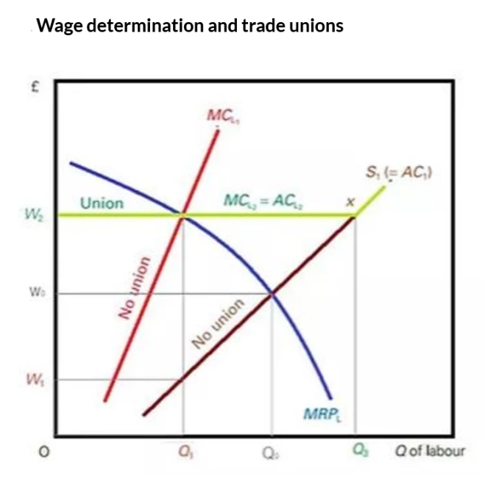

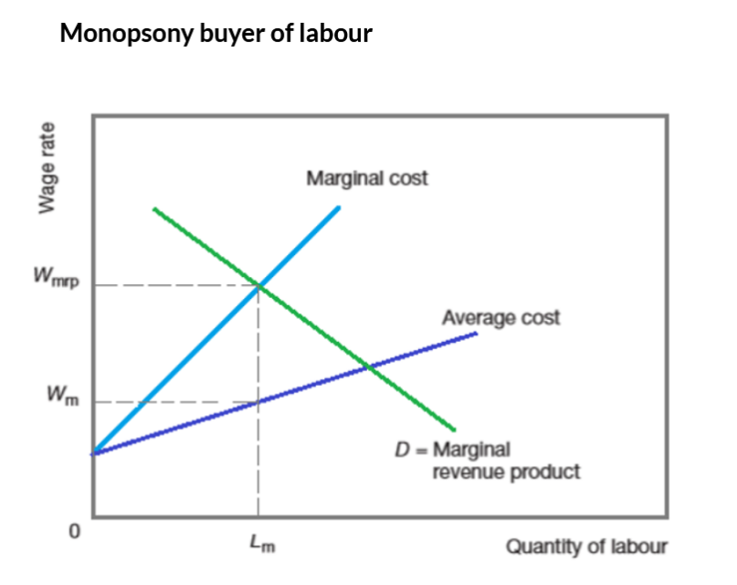

**Labour demand and/or supply**

Th e price of depends on demand and supply As the demand curve refl ects the value of the marginal product of labour, in equilibrium workers receive the value of their contribution to the production of goods and services. Each firm therefore purchases labour until the value of the marginal product equals the wage. Therefore, the wage paid in the market must equal the value of the marginal product of labour once it has brought demand and supply into equilibrium. Th e market therefore clears at the equilibrium wage. Th e labour market, however, is dynamic, like any market – any change in the demand or the supply of labour will change the equilibrium wage. Th e value of the marginal product of labour will also change by the same amount as, by definition, it must always equal the wage rate.

# Economic growth, economic development and sustainability

**Common keywords**

Economic growth

Developed and developing countries

GDP

**Questions**

|  |  |
| --- | --- |
| Distinguish between productivity and the level of production and discuss why productivity in a developing economy is likely to be lower than in a developed economy. [12]  ‘Rising population levels in a developing economy create many problems while falling population levels in a developed economy cause even greater problems.’ To what extent do you think this is a true statement? [13]  Economic growth should be the most important macroeconomic aim.’ Discuss this view.[12] | March 2021 42 |
| (a) Assess the impact of foreign direct investment (FDI) on developing economies. [12] (b) It is often stated that the problem of ‘a vicious cycle of poverty’ exists in developing countries. Explain what this means and discuss how this problem might be solved. [13] | 9708/41/M/J/19 |
| (a) Explain what is meant by actual economic growth and potential economic growth. [12] (b) ‘Health, education and savings are the most important factors in determining long-term development in developing countries.’ Comment on this statement. [13] | 9708/42/M/J/19 |
| (a) Distinguish between economic growth and economic development and consider whether they are linked. [12] (b) It is difficult to calculate the value of GDP and it does not provide an accurate measure of the welfare or happiness of a country’s citizens, therefore it should not be used as an indicator of the standard of living. Discuss whether you agree with this statement. [13] | 9708/41/O/N/18 |
| A country with an open economy has an increasing demand for its exports and a fall in the supply of labour. (a) Explain the effects of these changes on the general price level and national output in that economy. [12] | 9708/42/O/N/18 |
| (a) Explain how developing countries differ from developed countries. [12] (b) Assess the extent to which a multinational company’s investment in a developing country leads to economic growth. [13] | 9708/42/O/N/18 |
| ‘Both developed and developing economies can experience high levels of unemployment, high rates of inflation and large current account deficits. Therefore there is now no real difference between these two types of economy’. How far would you agree with the view that this statement is misleading? [25] | 9708/41/M/J/18 |
| (a) Explain the difference between actual growth and potential growth. [12] (b) To what extent do you agree that the costs of economic growth are greater than the benefits? [13] | 9708/42/M/J/18 |
| Economic development can only be achieved by economic growth and this depends solely on higher levels of government investment. To what extent would you agree with this statement? [25] | 9708/43/M/J/18 |
| The table shows economic growth rates of GDP for selected countries for 2013. (a) Does this table mean that Zimbabwe and Uganda should be classified as developed countries and Switzerland and Sweden as developing countries? [12] (b) Discuss why developing countries often aim to increase economic growth. [13] | 9708/43/O/N/17 |
| Economic models have little practical relevance. Discuss whether this is true of the analysis of how a fall in interest rates might affect an economy’s GDP. [25] | 9708/42/M/J/17 |
| (a) Consider whether the main cause of economic growth is an increase in population, and hence in labour supply. [12] (b) Do you agree that a country should try to increase its rate of economic growth? [13] | 9708/42/F/M/16 |

**Definitions and diagrams**

**Economic growth**

Economic growth in the short run is an increase in a country’s output and in the long run is an increase in a country’s productive potential.

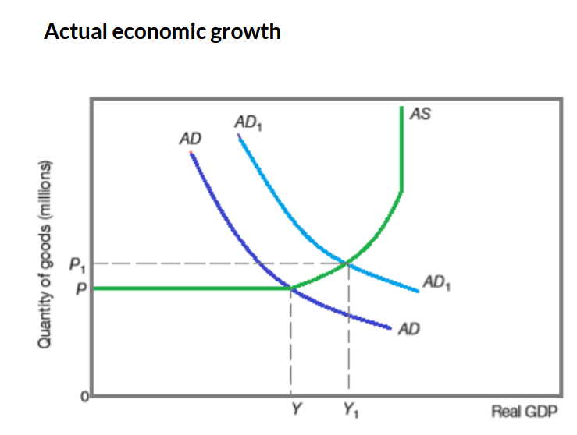

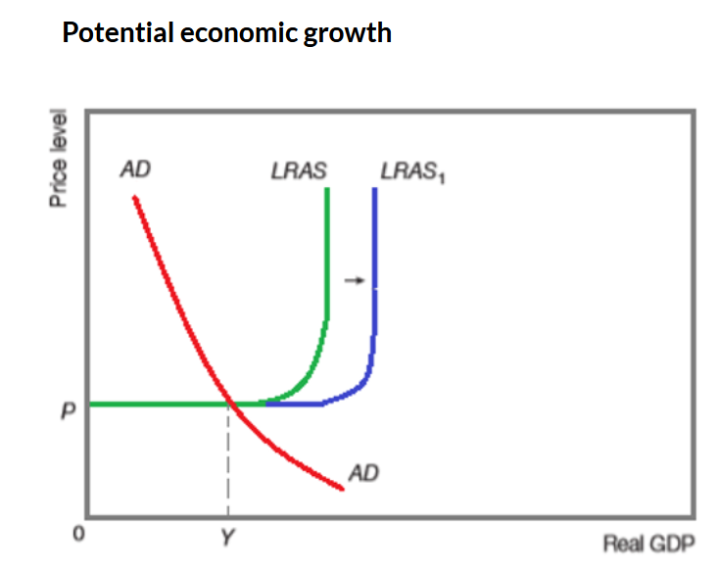

**Developed and developing countries**

Developed economies are high-income countries. Th ey have mature markets, high standards of living, high levels of productivity and a number of other characteristics that are discussed below. Developed economies are economies with high GDP per head. Developing economy is an economy with a low GDP per head.

**GDP**

Th e most widely used measure of national income is known as gross domestic product (GDP). Gross means total, domestic refers to the home economy and product means output. . GDP is calculated by adding up consumers’ spending, government spending on goods and services, total investment, changes in stocks and the difference between exports and imports

# Unemployment, recession and inflation

**Common keywords**

Structural, frictional, cyclical and seasonal unemployment

Solving the problem of unemployment

**Questions**

|  |  |
| --- | --- |
| Explain why an economy might be in equilibrium at less than a full employment level of output and critically evaluate alternative policy measures which might be used to move the economy to a full employment level of output. [25] | March 2021 41 |
| (b) How far do you agree with the view that an expansionary fiscal policy will reduce the level of unemployment in the short run but it will cause inflation to accelerate and unemployment to rise in the long run? | 9708/41/O/N/19 |
| Cyclical and structural unemployment are the most common types of unemployment. Explain the causes of these types of unemployment and assess the effectiveness of government policies to reduce them. [25] | 9708/42/M/J/19 |
| ‘Keynesian policies to solve the problem of unemployment will not work because they will conflict with the attainment of other key macroeconomic aims.’ Assess the accuracy of this statement. [25] | 9708/42/F/M/19 2 |
| Recession in some economies has caused high unemployment. At the same time high levels of national debt and substantial budget deficits have been experienced. This means that governments can no longer use Keynesian demand management policies to solve the problem of unemployment. To what extent do you agree with this conclusion? [25] | 9708/41/O/N/18 |
| Robots are increasingly used in various areas of production. (a) Explain the type of unemployment which may arise as a result of the increased use of robots. Consider the contribution this may make to total unemployment in an economy. [12] | 9708/42/O/N/18 |
| (a) Explain what is meant by the term ‘natural rate of unemployment’. Consider which types of unemployment would cause this rate to rise. [12] (b) Some economists argue that government intervention is the best way to reduce the natural rate of unemployment while others suggest that it would be better to allow market forces to reduce this type of unemployment. Compare both approaches and assess which is likely to be the more effective. [13] | 9708/43/O/N/18 |
| (a) Distinguish between structural and frictional unemployment. Consider which would be likely to have the greater negative effect on an economy. [12] (b) Assess the view that supply-side policies are the most effective way to solve the problem of structural unemployment. [13] | 9708/41/M/J/18 |
| In 2016, governments in some countries were concerned about inflation, whilst the governments of other countries were concerned about recession. (a) Consider how the causes of recession may differ from the causes of inflation. [12] (b) Examine the view that ‘recession can only be solved by monetary policy’. [13] | 9708/42/M/J/18 |
| (a) Explain the quantity theory of money. Consider its relevance to economic policies that might be used to control inflation. [12] (b) The Phillips curve suggests that inflation can only be controlled at the expense of higher levels of unemployment. To what extent do you agree with this view? [13] | 9708/43/M/J/18 |
| In many countries there is a concern about the rate of unemployment. (a) Consider what are likely to be the main causes of unemployment. [12] (b) Discuss whether a reduction in unemployment should always be the main aim of government policy. [13] | 9708/42/O/N/17 |
| (a) Analyse what might cause an increase in unemployment in an economy. [12] (b) Discuss what impact an increase in unemployment is likely to have on an economy. [13] | 9708/43/O/N/17 |
| (a) How might the employment composition and age structure of a developing country differ from those of a developed country? [12] (b) Apart from the employment composition and age structure, discuss what changes are likely to occur in a developing country if it progresses towards developed status. Consider whether these changes are always beneficial. | 9708/42/F/M/17 |
| (a) Explain the causes of unemployment and consider what type of unemployment is the most serious for the country in which you live. [12] | 9708/42/O/N/16 |
| Explain the difference between structural, cyclical and seasonal unemployment and discuss whether a general rise in income in a country would have the same effect on each of these types of unemployment. [13] | June 2015 42 |
| (b) How far do you agree with the view that an expansionary fiscal policy will reduce the level of unemployment in the short run but it will cause inflation to accelerate and unemployment to rise in the long run? |  |

**Definitions and diagrams**

**Structural, frictional, cyclical and seasonal unemployment**

Structural unemployment is unemployment caused as a result of the changing structure of economic activity.

Frictional unemployment is unemployment that is temporary and arises where people are in-between jobs

Cyclical employment is unemployment that results from a lack of aggregate demand.

Seasonal unemployment occurs when people are unemployed at particular times of the year when demand for labour is lower than usual.

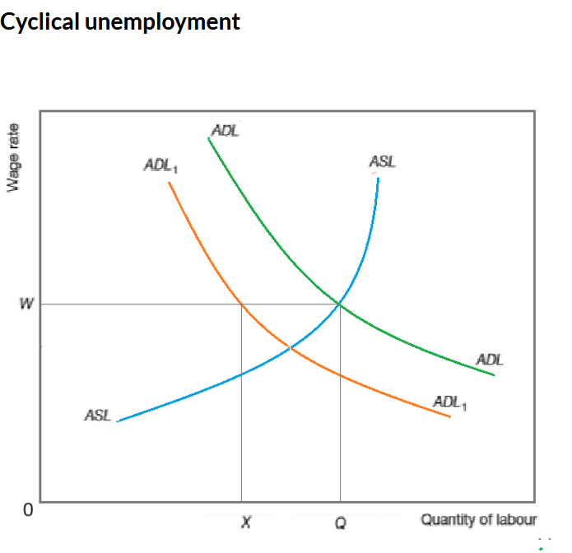

**Solving the problem of employment**

To reduce cyclical unemployment, a government will use reflationary fiscal or monetary policy measures to increase aggregate demand. To reduce frictional and structural unemployment, a government is likely to introduce supply side policy measures

# National income statistics and classification of countries

**Common keywords**

**GDP**

Th e most widely used measure of national income is known as gross domestic product (GDP). Gross means total, domestic refers to the home economy and product means output. . GDP is calculated by adding up consumers’ spending, government spending on goods and services, total investment, changes in stocks and the difference between exports and imports

**Living standards**

Standard of living refers to the quantity and quality of material goods and services available to a given population.

**Economic indicators**

National income statistics are used to compare countries’ economic performance and to give a perspective to key economic indicators.

Money GDP is the total output measured in current prices. Real GDP is the total output measured in constant prices. Purchasing power parity (PPP): a way of comparing international living standards by using an exchange rate based on the amount of each currency needed to purchase the same basket of goods and services.

**Questions**

|  |  |
| --- | --- |
| ‘The Human Development Index (HDI) is a more useful indicator of changes in living standards than changes in Gross Domestic Product (GDP) but it still does not provide an entirely accurate assessment of whether living standards have improved over a given time period.’ Critically evaluate this statement. [25] | 9708/41/O/N/19 |
| ‘There have been many attempts to measure changes in living standards both within and between countries. Although some have been more useful than others, none of these alternative measures has produced a sufficiently accurate, reliable indicator of changes in living standards.’ How far would you agree with this statement? [25] | 9708/43/O/N/19 |
| Discuss whether GDP is always a good measure of living standards. [13] | 9708/42/O/N/18 |
| (b) Discuss whether an increase in the national income of a country is a reliable indication of an improvement in the standard of living for the people in that country. | 9708/42/F/M/17 |
| Governments want to increase the standard of living in their country. Discuss whether the indicators used to measure the standard of living are reliable and consider what policies a government might use to try to increase the standard of living in its country. [25] | 9708/42/F/M/16 |
| The government of your country wants to know how the economy compares with other countries’ economies. Discuss which economic indicators it should obtain and how reliable they might be as a basis for such a comparison. [25] | 9708/42/O/N/15 |
| In 2012, a table for Gross Domestic Product (GDP) per head showed that only three of the world’s ten richest countries had populations above 7 million. These were the United States: 315 million; the United Arab Emirates: 8.2 million; and Switzerland: 8 million. (a) Explain how GDP is calculated and show how GDP at market prices is different from net national income at factor cost (basic prices). [12] | Jun-15 |

# Developed countries, developing countries and living standards

**Common keywords**

Developed and Developing countries

Developed economies are economies with high GDP per head. A developing economy is one that has a low income per head.

**Questions**

|  |  |
| --- | --- |
| (a) ‘Developing countries have low levels of productivity and a high dependency ratio.’ Explain the meaning of these two characteristics and consider whether they are linked. [12] (b) Assess the view that foreign direct investment remains the key to economic growth in developing countries. [13] | May 2020 41 43 |
| (a) Compare the characteristics of developed and developing countries. [12] (b) Discuss whether gross domestic product (GDP) is the best measure of a country’s standard of living. [13] | May 2020 42 |
| Discuss whether countries at different stages of development should use different methods of measuring living standards. [25] | 9708/42/O/N/19 |
| Some developing countries pursue export-led growth and argue that the overall growth of the economy can be generated not only by increasing the amounts of labour and capital but also by expanding exports. Other developing countries prefer to promote growth by encouraging investment by foreign multinational corporations.Compare these approaches and assess which is likely to be the more effective. [25] | 9708/42/F/M/18 |
| ‘The measurement of living standards is problematic. It is never certain that people in one country are better off than those in another. The classification of countries into developing and developed is, therefore, never clear.’ Do you agree with this argument? [25] | 9708/41/O/N/17 |
| Whether a country can be classified as developed depends on the value of its GDP and the higher the GDP the better it is for the country. Consider this opinion. [25] | 9708/42/O/N/17 |
| (a) Explain why some countries are referred to as developing. Suggest why the expected increase in population in developing economies is thought to be a source for concern. [12] (b) Discuss what the government of a developing country might do to enable its economy to become more developed. [13] | 9708/41/M/J/17 |
| (a) Developed countries sometimes prevent investment in rural areas while developing countries often encourage rural development. Consider why this might be so. [12] (b) Why is it important to use qualitative data as well as quantitative GDP data when considering whether a country is developed or developing? [13] | 9708/42/M/J/17 |
| All countries hope to cause their economies to expand and develop through economic growth. (a) Explain what is meant by economic growth. Consider why, if all countries are developing, some are called developed countries. [12] (b) Would you agree that for a developed country with unused resources economic growth is only ever beneficial? [13] | 9708/43/M/J/17 |
| (a) Explain what is most in need of development in a developing economy. [12] (b) Discuss how easy it is to compare the standard of living between developing and developed countries. [13] | 9708/41/O/N/16 |
| (a) Conventional estimates of national income indicated that average income per head between 2009 and 2013 was US$98 780 in Norway and US$36 900 in New Zealand. Consider whether this means that the standard of living in Norway is nearly three times as high as in New Zealand. [12] (b) Norway and New Zealand are classified as developed countries. Make a judgement on what are the important distinguishing differences between a developed country and a developing country. [13] | 9708/42/O/N/16 |
| (a) Consider whether the main distinguishing feature of a developing economy is a low level of income per person. [12] (b) Are the problems that arise in estimating changes over time in national incomes significantly different depending on whether the countries are developing or developed? [13] | 9708/43/O/N/16 |
| People in developed countries suffer from pollution and overcrowding. However, people in developing countries suffer from malnutrition and poverty.’Discuss whether it is correct to distinguish between developed and developing countries in this way and consider how living standards can be compared between the two types of country. [25] | 9708/41/O/N/15 |
| Economic development and the exploitation of resources can result in structural change and unemployment in some industries, increased environmental damage, overexploitation of fish stocks, increased inequalities in the distribution of income and pressure on resources causing inflation.Explain what is meant by a developing economy and discuss whether it would be wise to conclude from the above opinion that developing countries should, therefore, not seek to become developed.[25 | 9708/43/O/N/15 |
| In 2012, a table for Gross Domestic Product (GDP) per head showed that only three of the world’s ten richest countries had populations above 7 million. These were the United States: 315 million; the United Arab Emirates: 8.2 million; and Switzerland: 8 million.(b) Classifications often distinguish between developed (rich) and developing (poor) countries. Consider in what sense a developing country is said to be ‘poor’ and discuss whether the best way to become developed (rich) would be to reduce the size of its population. [13] | June 2015 41 |
| The table shows figures for annual GDP growth rates at market prices for three developing countries, Bangladesh, Ethiopia and Malawi, and three developed countries, Greece, UK and USA.(a) Describe what is meant by economic growth and consider if it is always advantageous. [12] (b) Explain what is meant by a developing country and a developed country and consider whether the table supports the idea that GDP growth rates are a good indicator of development. [13] | June 2015 42 |

# Circular flow of income

**Common keywords**

**Leakage and injection**

For income to be unchanged it is also necessary for injections of extra spending into the circular fl ow of income to equal withdrawals from the circular fl ow. If injections were greater than leakages, there would be extra spending in the economy, causing income to rise. In contrast, if withdrawals exceed injections, more spending would be added to the circular fl ow and income would fall.

**Questions**

|  |  |
| --- | --- |
| Evaluate how the relative size of injections into and leakages from the circular flow of income can affect the ability of a government to achieve its macroeconomic aims. [25] | 9708/42/O/N/19 |
| (a) Distinguish between leakages and injections in the circular flow of income and consider how they might be related. [12] (b) Critically evaluate a central bank’s use of interest rates to increase injections into an economy. [13] | 9708/42/F/M/19 |
| ‘Lack of consumer spending causes recessions. Recessions do not improve a country’s standard of living. It is always better, therefore, to encourage consumer spending for this improves a country’s standard of living.’ (a) What is a recession and is it always caused by a lack of consumer spending? [12] (b) Discuss what policies a government may use to try and end a recession. [13] | June 2015 42 |

# Investment

**Common keywords**

**Investment**

**Questions**

|  |  |
| --- | --- |
| One macroeconomic indicator is the level of investment. (a) What determines the level of investment? [12] (b) Discuss how a large increase in the level of investment may affect an economy and whether such an increase is always beneficial. [13] | June 2015 43 |
| In 2013, a new aircraft, the Boeing 787 Dreamliner, was assembled in the United States (US). United Airlines, an American private company, ordered 50 of these aircraft, each costing over US$200 million.    (a) Imagine that the US was a closed economy with no government intervention. Analyse why the increase in national income from this investment in new aircraft might be different than if it were an open, mixed economy. [12]    (b) Discuss the policies that a government might use to influence the level of investment in an economy. [13] |  |
| (a) Assess how changes in interest rates might influence investment. [12]    (b) Some argue that increases in investment cause national income to increase. Others argue that the reverse is true: an increase in national income brings about investment. Discuss whether both these seemingly contradictory statements can be true. [13] | 9708/42/F/M/16 |
| (a) Explain the difference between autonomous investment and induced investment. Consider whether there is a link between these two types of investment. [12]    (b) ‘Governments should concentrate upon providing favourable conditions for investment by firms in the private sector. This would allow all investment in an economy to be carried out by firms in the private sector.’ How far would you support this view? [13] | 9708/42/F/M/18 |
| (a) Explain what are the main determinants of business investment. [12]    (b) ‘If investment increases it will cause an increase in output. If output increases it will cause an increase in investment.' Discuss whether both these statements can be true. [13] | 9708/41/O/N/15 |
| Businesses say that high interest rates are not desirable because they prevent investment. Government ministers say that high interest rates are sometimes necessary because they encourage saving and control inflation.Discuss these two opinions and decide whether they are always true. [25] | 9708/42/O/N/1 |

**Definitions and diagrams**

**Investment**

 Investment is spending by firms on capital goods

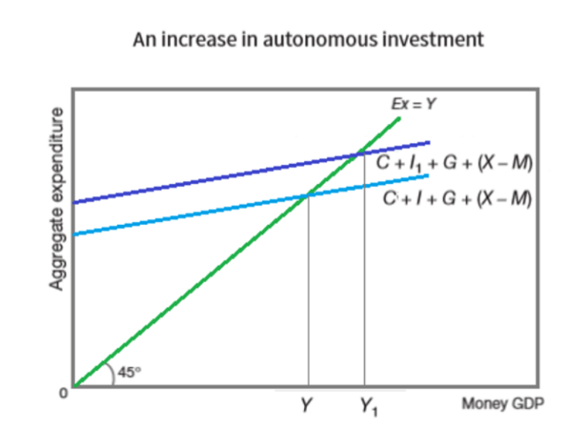

# Money supply

**Common keywords**

Quantitative easing

Demand for money

Interest rate

**Questions**

|  |  |
| --- | --- |
| (a) Explain the Keynesian theory of the determination of the rate of interest. [12] | May 2020 42 |
| (b) Discuss the impact on the economy of the introduction of quantitative easing (QE) by the central bank. [13] |  |
| (a) Discuss the effects of an expansionary monetary policy on the demand for money. [12] | 9708/41/O/N/19 |
| (a) Explain the speculative motive for the demand for money and consider its significance in relation to monetary policy. [12] | 9708/43/O/N/19 |
| (b) Discuss the view that monetary policy can be used effectively to control demand-pull inflation but not to control cost-push inflation. [13] |  |
| Distinguish between the internal value of money and the external value of money and consider whether there is a link between these two values. [12] (b) ‘Policies which attempt to control the internal value of money will automatically make it difficult to control the external value of money.’ Discuss the view that this statement is only partially correct. [13] | 9708/41/M/J/19 |
| ‘The failure of the policy of quantitative easing (QE) to solve problems associated with an economic recession illustrates the weakness of monetary transmissions mechanisms in particular and monetary policy in general.’ Critically evaluate this statement. [25] | 9708/41/M/J/19 |
| (a) The US Federal Reserve (the country’s central bank) has pursued a policy of quantitative easing (QE) for several years. Explain how quantitative easing affects the level of economic activity in a country. [12] | 9708/42/M/J/19 |
| (b) Discuss how far (i) an increase in wages and (ii) a loss of business confidence might affect the rate of interest. [13] |  |
| (a) Examine the effects on the demand for money in an economy, when the money supply is increasing and more individuals are using credit and debit cards instead of cash to purchase goods and services. [12] | 9708/41/O/N/18 |
| (b) Quantitative easing will lead to lower interest rates and it will depreciate the value of the national currency. This will automatically lead to high levels of inflation. To what extent do you agree with this view? [13] |  |
| A country with an open economy has an increasing demand for its exports and a fall in the supply of labour. (b) Consider the effectiveness of using only monetary policy in this situation. [13] | 9708/42/O/N/18 |
| 6 (a) ‘Central banks can control interest rates but they cannot control the money supply. Commercial banks can control the money supply but they cannot control interest rates.’ To what extent would you agree with this statement? [12] (b) ‘Monetary policy alone is unlikely to have any significant effect on real variables such as the level of output but it is the only effective way to control inflation’. Critically evaluate this view. [13] | 9708/43/O/N/18 |
| (a) Consider the extent to which the commercial banks can influence the money supply. [12] | 9708/41/M/J/18 |
| (b) ‘Quantitative easing has a limited effect on employment in the short run and is likely to cause inflation in the long run.’ Discuss whether there is any truth in this statement. [13] |  |
| Distinguish between the transactions demand for money and the speculative demand for money. Consider which is likely to be more important for a consumer in a modern economy. [12] (b) Some economists argue that large budget deficits will increase the demand for money while others argue that large budget deficits will decrease the demand for money. Discuss whether it is possible to reconcile these views. [13] | 9708/42/F/M/18 |
| (a) Consider how significant the level of income is in determining people’s demand for money, according to liquidity preference theory. [12] | 9708/42/F/M/17 |
| (a) Explain the reasons why people demand money according to the liquidity preference theory. Consider which reason is the most important. [12] (b) In 2015, after a period of low inflation and low interest rates a commentator wrote, ‘If inflation suddenly increases it could result in a faster than expected rise in interest rates. The consumer spending boom will end.’ (Source: London Evening Standard, 26 January 2015) Discuss the possible reasons behind this suggested result. [13] | 9708/41/M/J/17 |
| (a) Explain why people demand money according to the liquidity preference theory. [12] (b) In 2016 the Trade Unions called a strike of bus and train drivers after a demand for higher wages was rejected. Use the economic theory of wages to discuss whether a demand for higher wages is likely to be successful. [13] | 9708/42/M/J/17 |
| (a) ‘National income is the only determinant of the demand for money.’ Do you agree with this statement? [12] (b) Assess how alternative macroeconomic policies might affect the demand for money. [13] | 9708/43/O/N/16 |
| (b) Analyse whether there is a link between the reasons given by the liquidity preference theory as to why people demand money and the rate of interest. [13] | 29708/41/O/N/15 |
| (a) Explain the motives for the demand for money according to the Keynesian liquidity preference theory. [12] (b) A worker is a weekly paid shop assistant. She is then promoted to a manager in a larger store on a higher monthly salary. At the same time interest rates fall. Discuss how these changes would affect the worker’s demand for money. [13] | 9708/42/O/N/15 |
| In a number of countries interest rates have remained low for a long time. Some people have been unhappy with the low rates but others have been pleased. However, high interest rates also cause different reactions. (a) Explain why different groups of people may differ in their reaction to the level of interest rates.[12] (b) Discuss whether a low interest rate can help a government achieve its macroeconomic aims.[13] | 39708/43/O/N/15 |

**Definitions and diagrams**

**Quantitative easing**

When the rate of interest is very low, a central bank may decide to try to increase aggregate demand by engaging in quantitative easing. Th is involves a central bank buying government bonds from financial institutions, including commercial banks, in order to increase the money supply. With more liquid assets, it is hoped that the commercial banks will lend more which will increase investment and consumer expenditure and so aggregate demand and economic activity

**Demand for money**

Liquidity preference is a Keynesian concept that explains why people demand money. Th ere are three main motives for households and firms to hold part of their wealth in a money form. Transactions motive is the desire to hold money for the day-to-day buying of goods and services. Precautionary motive is a reason for holding money for unexpected or unforeseen events. Speculative motive: a reason for holding money with a view to make future gains from buying financial assets

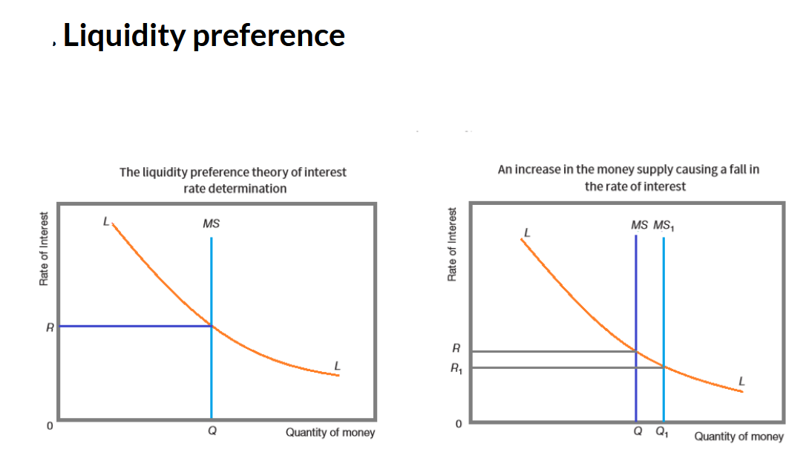

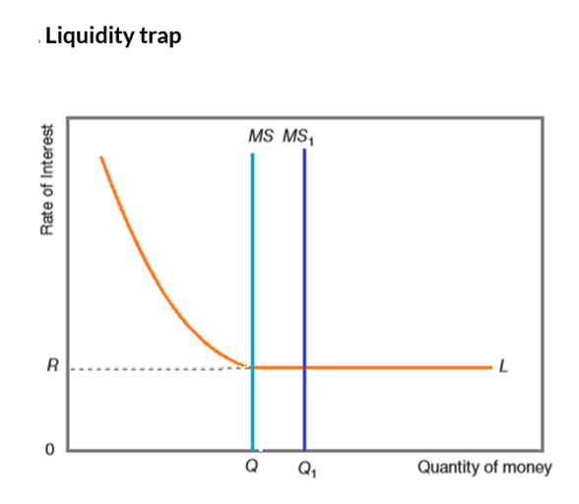

**Interest rate**

Interest rate is the price of borrowing money and the reward for saving.

# Government macroeconomic intervention

**Common keywords**

 Fiscal, monetary and supply side policy

Government macroeconomic aims

**Questions:**

|  |  |
| --- | --- |
| To what extent do you agree that it is not possible to solve a persistent balance of payments deficit without sacrificing other key macroeconomic aims?[13] | March 2021 42 |
| In January 2018 tax reductions were introduced in the US, and the Federal Reserve Bank (the US central bank) announced it would raise interest rates later in the year. Discuss how these policies may cause conflicts for a government in trying to achieve its macroeconomic aims. [25] | May 2020 42 |
| (a) What differences are there, if any, between fiscal policies, monetary policies and supply side policies? [12] | 9708/41/O/N/17 |
| (a) Estimates in 2015 put the GDP of New Zealand at US$191 billion, Peru at US$190 billion and Romania at US$189 billion. Are these figures a sufficient indication that the standard of living in the three countries was very similar? [12] (b) Distinguish between monetary policy and fiscal policy. Discuss whether fiscal policy may be used to influence the standard of living in a country. [13] | 9708/43/M/J/17 |
| (a) Explain three major government macroeconomic policy aims and describe why there may be a conflict in trying to achieve them at the same time. [12] (b) Governments are sometimes concerned with microeconomic issues, for example, planning applications for large projects such as airports which have environmental implications. Discuss how a government’s decision on a microeconomic issue might have macroeconomic implications. | 9708/41/O/N/16 |
| (b) Discuss whether government macroeconomic aims of full employment, economic growth and price stability are likely to conflict with each other. [13] | 9708/42/O/N/16 |
| (a) Explain why the government’s annual budget is an important instrument of economic policy.[12] | 29708/41/O/N/15 |
| In 2012, many smaller specialised city centre retailers struggled against competition from large supermarkets and online retailers. They were also badly affected by government fiscal policy. (a) Explain how small retailers could be badly affected by government fiscal policy. [12] (b) Economic theory suggests that competition is good. The statement from 2012 seems to imply that it is not. Discuss this difference of opinions and consider which you support. [13] | 9708/43/O/N/15 |

**Definitions and diagrams**

**Fiscal, monetary and supply side policy**

Fiscal policy is the use of taxation and government spending to influence aggregate demand.

Monetary policy is the use of interest rates, direct control of the money supply and the exchange rate to influence aggregate demand.

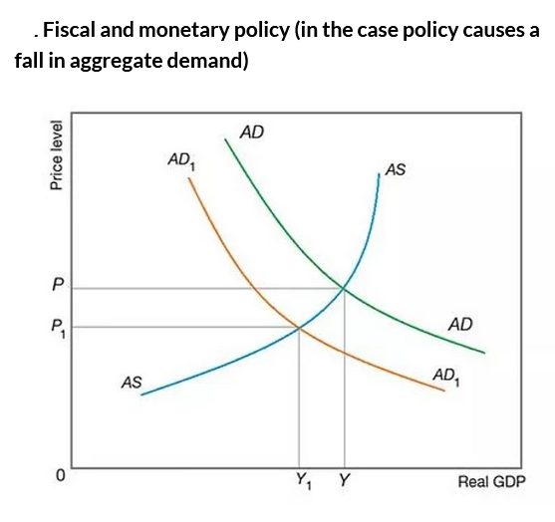

Supply side policies are measures designed to increase aggregate supply.

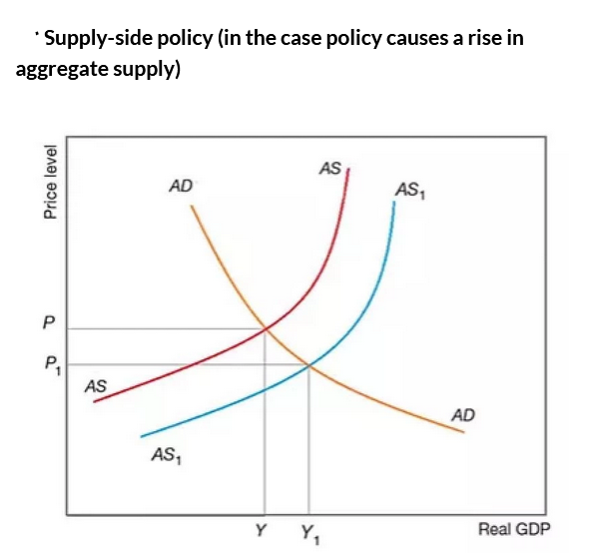

Government macroeconomic aims

The main government aims for the economy are full employment, price stability, economic growth, redistribution of income and stability of balance of payments.

# Inflationary gap and deflationary gap

**Common keywords**

Inflationary gap

Deflationary gap

**Questions:**

|  |  |
| --- | --- |
| (a) Explain what economists mean by an inflationary gap and discuss why this is considered to be an economic problem. Use a diagram(s) to support your answer. [12] (b) How far would you agree that the use of monetary policy is the most effective way to solve the problem of an inflationary gap? [13] | May 2020 41 -43 |
| (a) Explain what economists mean by a ‘deflationary gap’ and discuss why this could be considered problematic for an economy. Use a diagram to illustrate your answer. [12] (b) How far would you agree that the use of budget deficits is the most effective way to solve the problem of a deflationary gap? [13] | 9708/43/M/J/18 |

**Definitions and diagrams**

Inflationary gap

Inflationary gap is the excess of aggregate expenditure over potential output (equivalent to a positive output gap)

Deflationary gap

Deflationary gap is a shortage of aggregate expenditure so that potential output is not reached (equivalent to a negative output gap)

